**How to import the files from PC to tin0 and from tin0 to Cloud Stack virtual machine**

**Step 1:** **Installing WinSCP**

WinSCP is a free and open-source SFTP, FTP, WebDAV, Amazon S3 and SCP client for Microsoft Windows. Its main function is secure file transfer between a local and a remote computer.

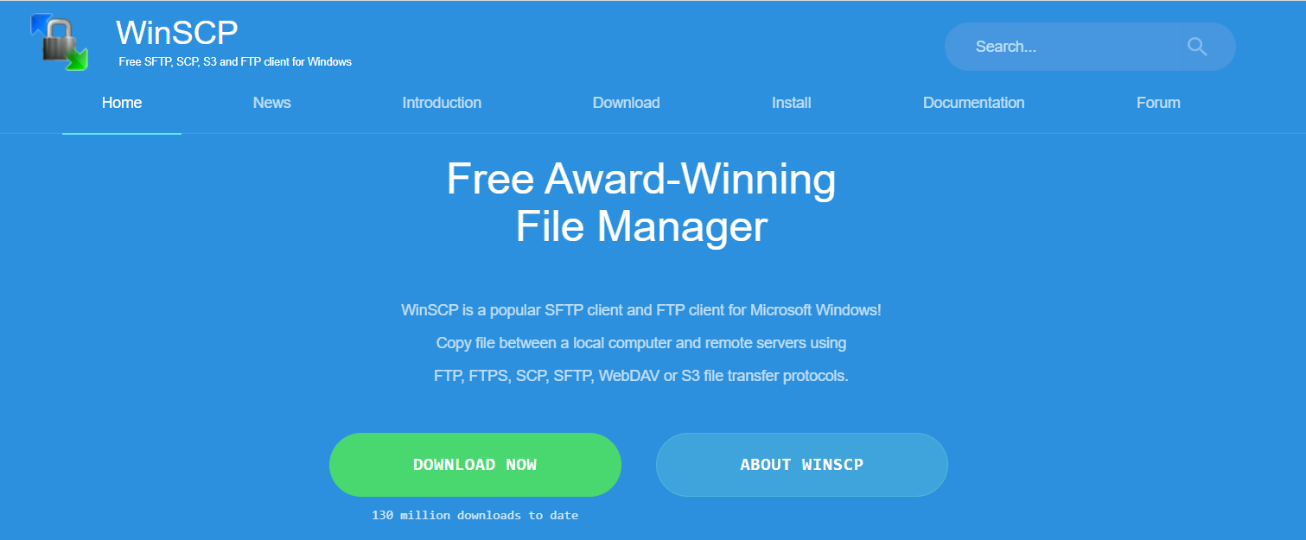

Download WinSCP here: <https://winscp.net/eng/index.php> for Windows.

**Step 2: Connecting to tin0 with WinSCP**

First, connect to GlobalProtect. Then, connect to tin0 through ssh by following steps below. Tin0 IP address is 192.168.200.20, port # is 22. Enter those credentials with a username & password.

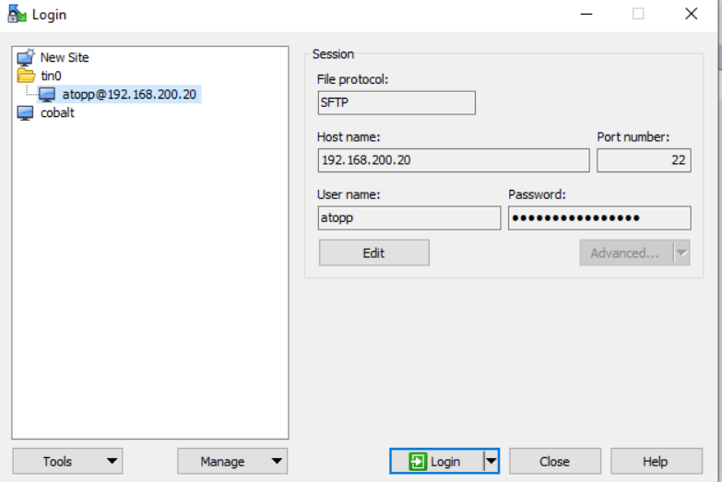

Enter tin0 user`s password again.

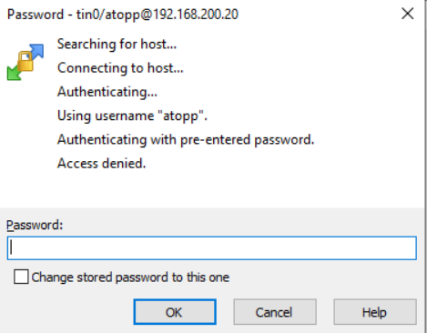

When in the tin0 directory, drag the files from PC directory to tin0 directory and uploading will start.

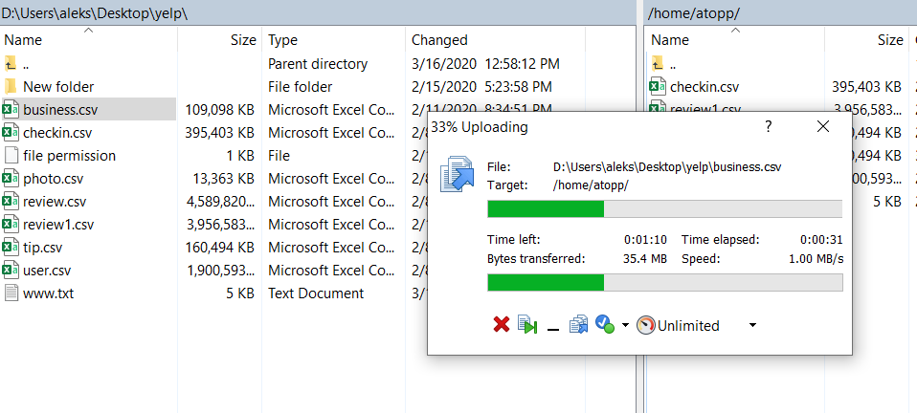

**Step 3: Install PuTTY**

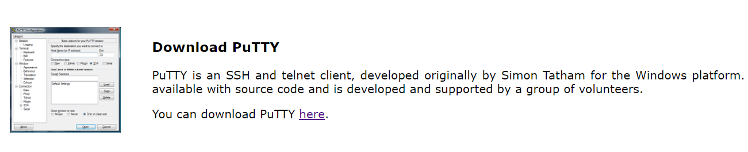

Installation link: <https://www.chiark.greenend.org.uk/~sgtatham/putty/latest.html>

**Step 4: Connect to tin0 through ssh in PuTTY.**

Open PuTTY and connect to the tin0 account where the files are. Tin0 IP address is 192.168.200.20 then open.

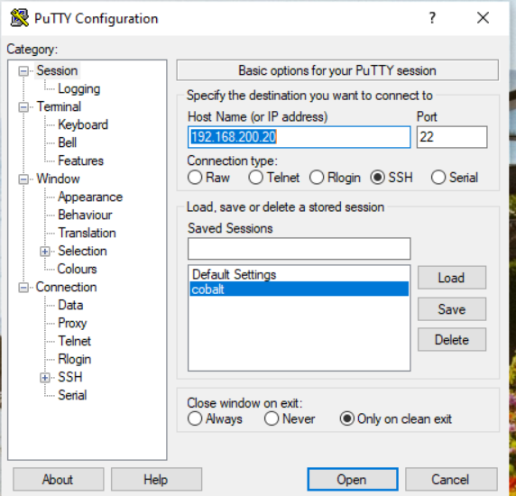

**Step 5:** Login with tin0 username and password where files are, and proceed with scp transfer commands below.

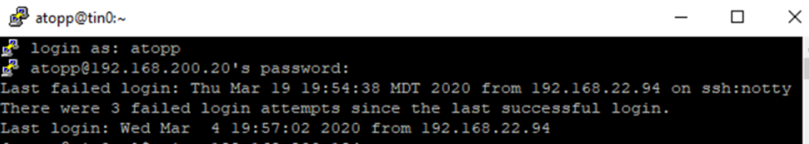

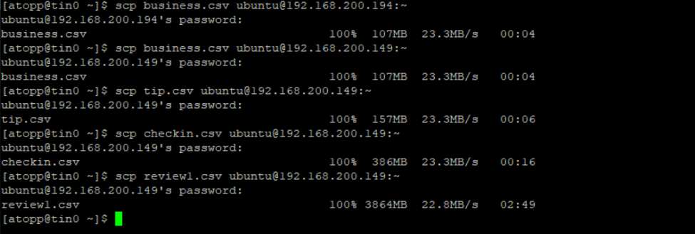

**Additional steps:**

If scp commands return error “connection refused”, try to install ssh on the virtual machine where the files are being transferred, if it is not yet installed.

First update the system using the apt command or apt-get command:  
$ sudo apt update  
$ sudo apt upgrade

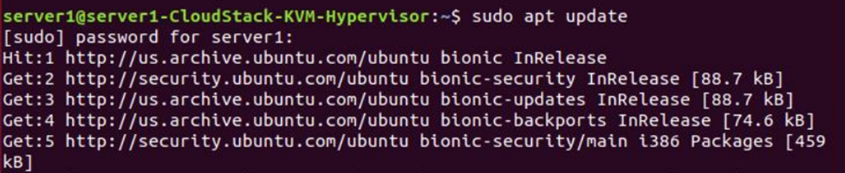

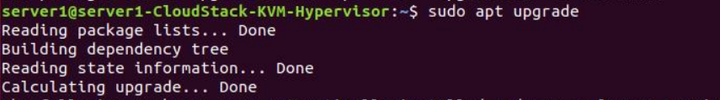

To install openssh-server package, run:  
$ sudo apt install openssh-server

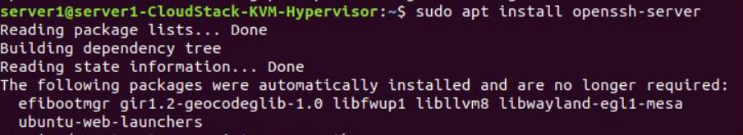

To verify that ssh service running type the command in terminal:

$ sudo systemctl status ssh

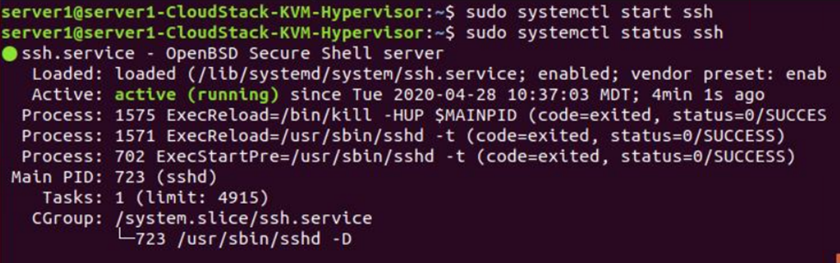

References

(n.d.). Retrieved from <https://www.chiark.greenend.org.uk/~sgtatham/putty/latest.html>

Free Award-Winning File Manager. (2020, April 27). Retrieved from <https://winscp.net/eng/index.php>

Gite, V., Gite, V., Gite, V., & Gite, V. (2019, October 14). Ubuntu Linux install OpenSSH server. Retrieved from <https://www.cyberciti.biz/faq/ubuntu-linux-install-openssh-server/>

Gite, V., Gite, V., Gite, V., & Gite, V. (2019, October 14). Ubuntu Linux install OpenSSH server. Retrieved from <https://www.cyberciti.biz/faq/ubuntu-linux-install-openssh-server/>